OBSOLETE: Sending to different I2C addresses (0x28 and 0x2f)

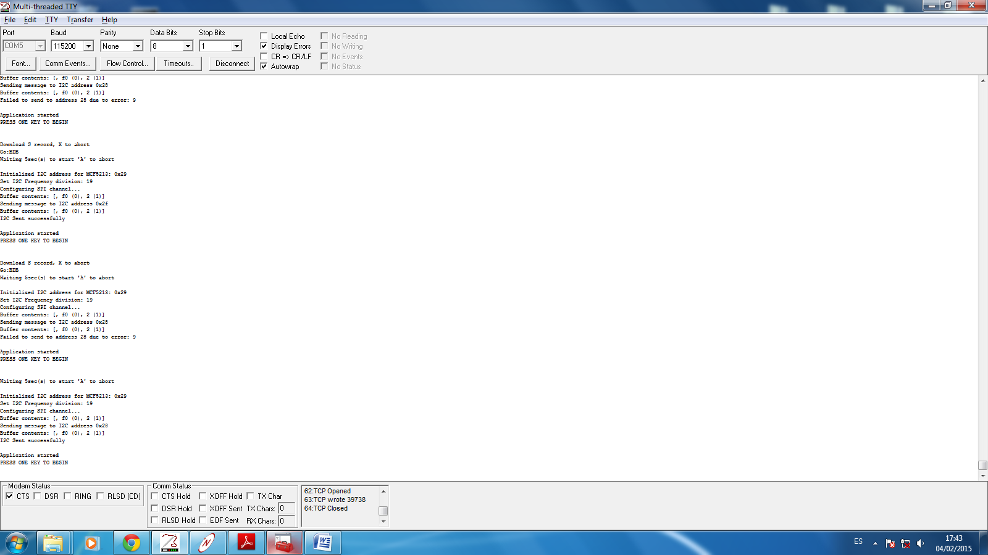



OBSOLETE: RESULT_TEST_I2CtoSPI_BRIDGE_ADDRESS 8/3/15

TEST_I2CtoSPI_BRIDGE_ADDRESS

SlotCard 851 – PASSED

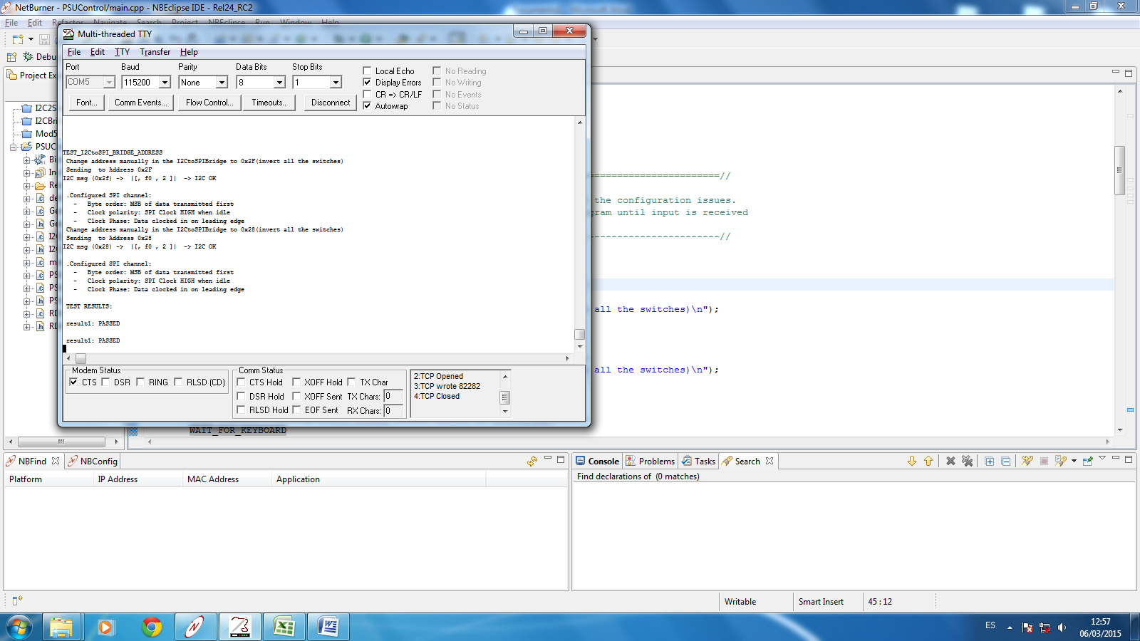

SlotCard 918 – NOT PASSED

